**Rahul Rai**

**20110156**

**Computer Architecture: Assignment 1**

Q1. (a) Using Recursion – Calculating the time for printing 100 numbers is not possible. In the worst case the algorithm needs to do 2100 instructions. Assuming the Clock rate to be 1Ghz, which means our laptop can handle approximately 109 instructions. Then also 1020 seconds will be left.

So, to calculate time using timespec, I calculated time to print first 50 numbers and after that calculated the time to print the next 50 numbers theoretically using the Time complexity of the algorithm.

To print 50 numbers, time required = 335618838700 nanoseconds

Time complexity of the Recursive Solution = 1.68 n

So Total Time = 335618838700 * (1.68) 50

Total Time = 618.458291866 * 1020 nanoseconds

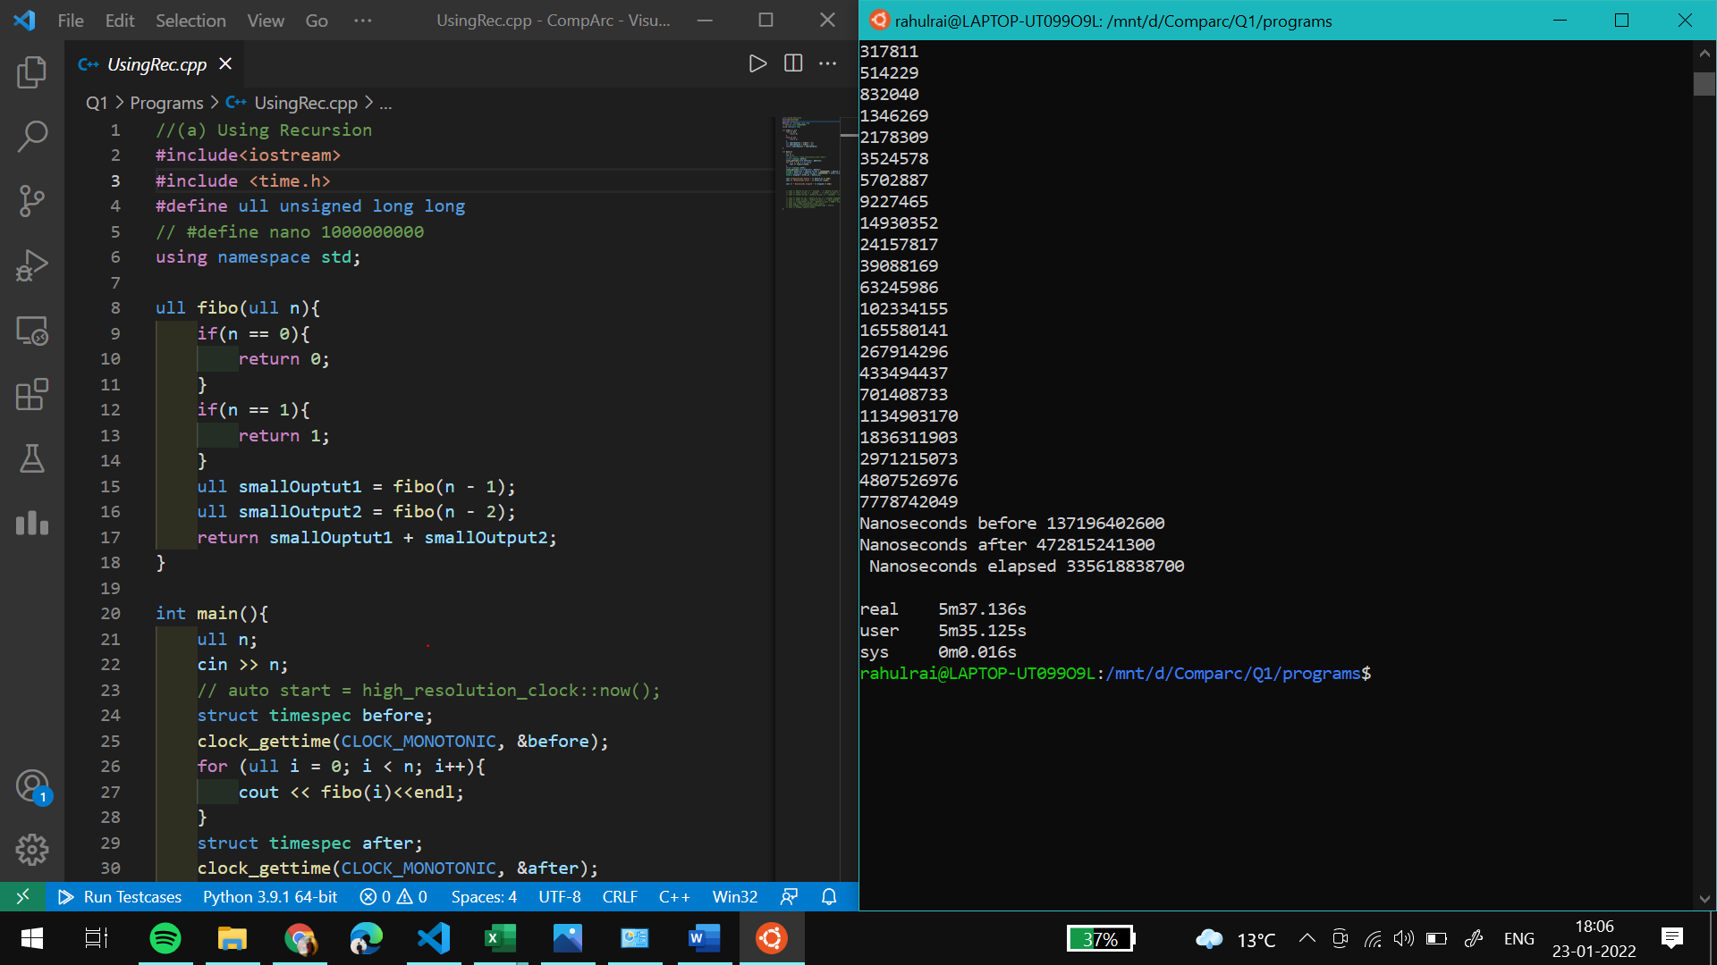

Figure Time using Timespec for first 50 numbers

I also tried to run the program for 3 hours but it was able to print first 54-55 numbers only. Below is the attached screenshot.

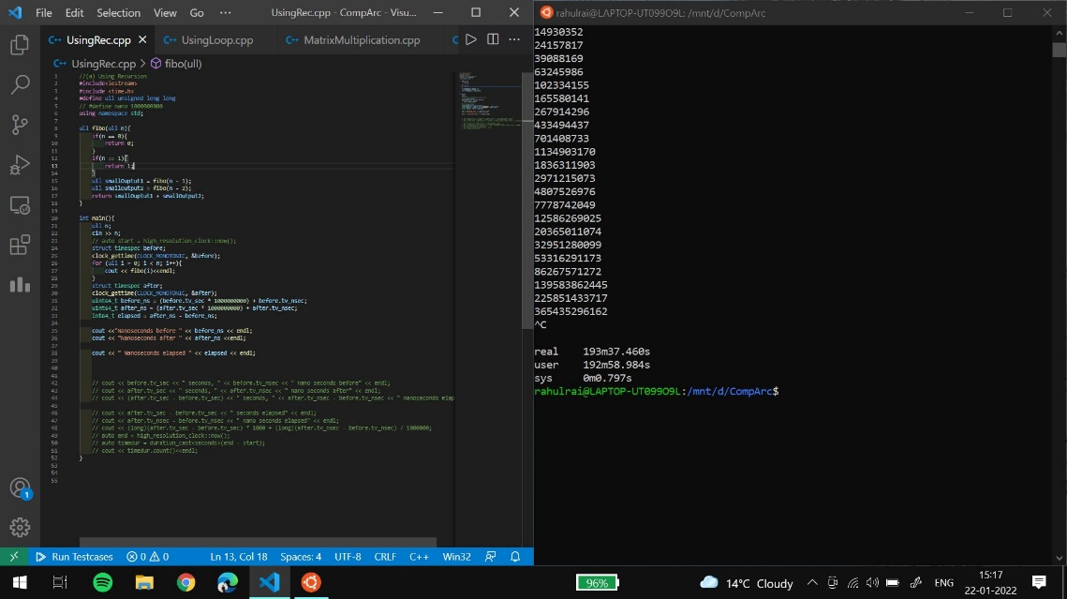

(b) Using Loop

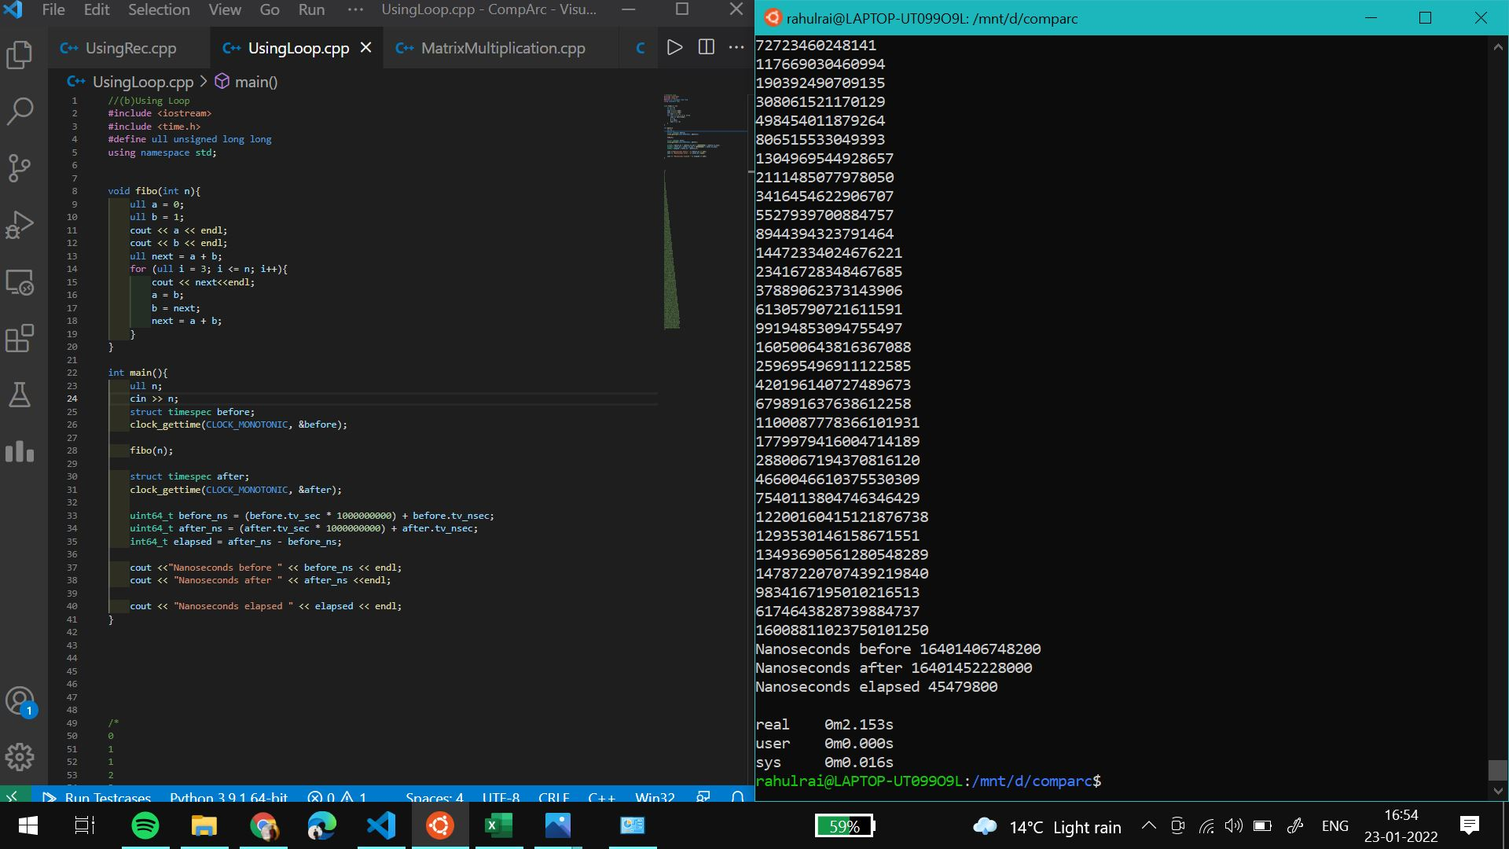

Time taken = 45479800 nanoseconds

(c) Using Recursion + Memoization

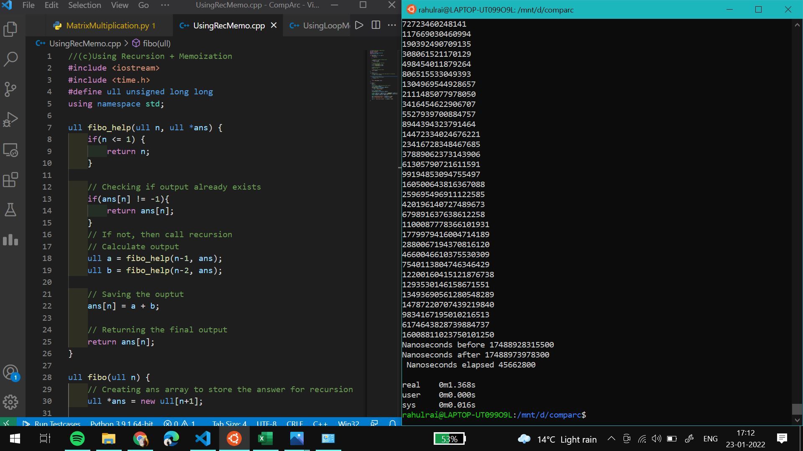

Time taken = 45662800 nanoseconds

(d) Using Loop and Memo

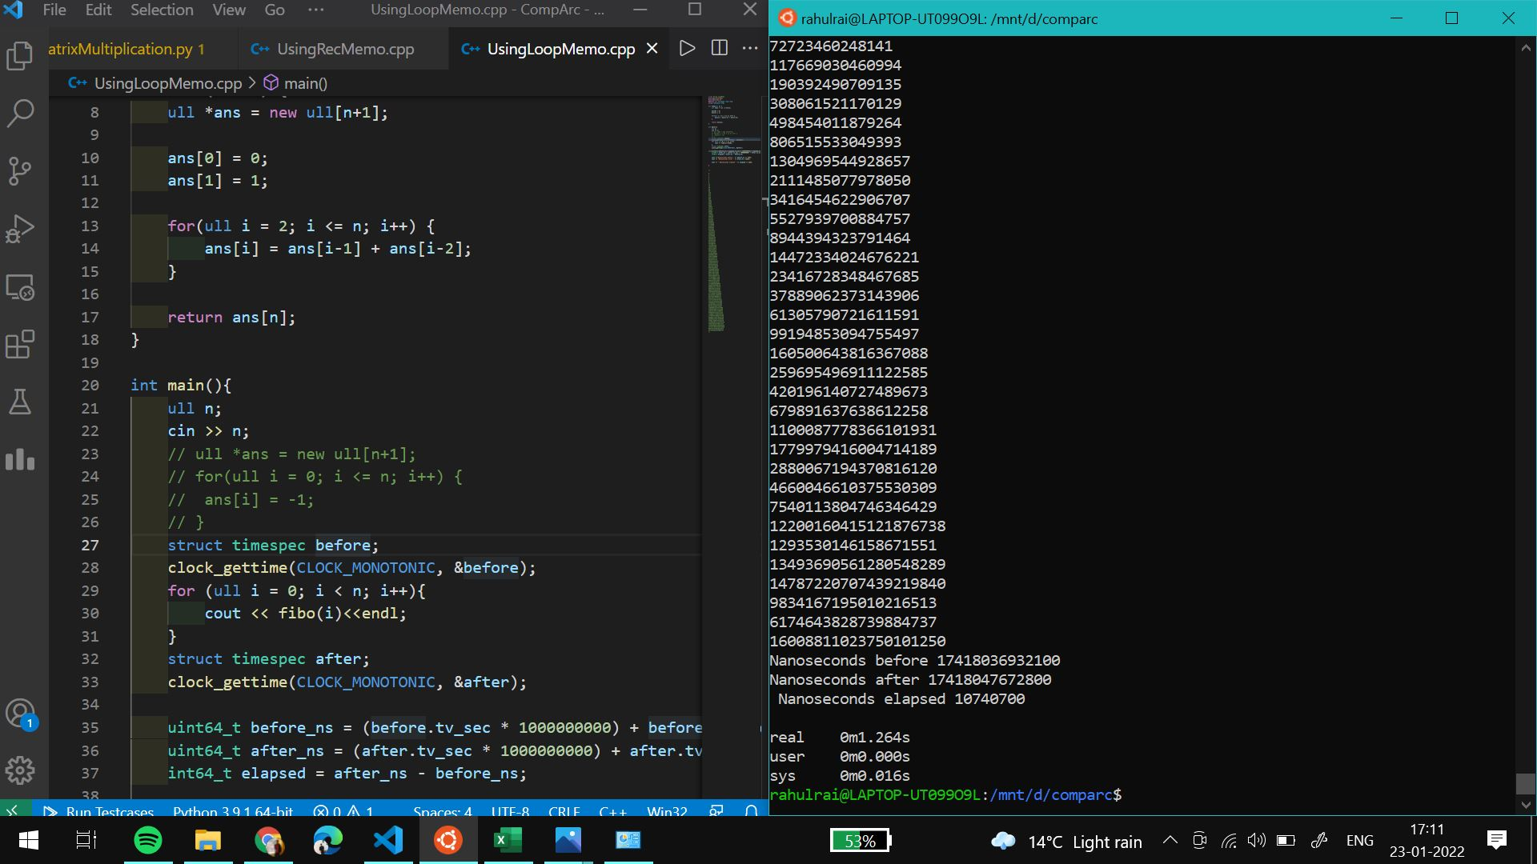

Time taken = 10740700 nanoseconds

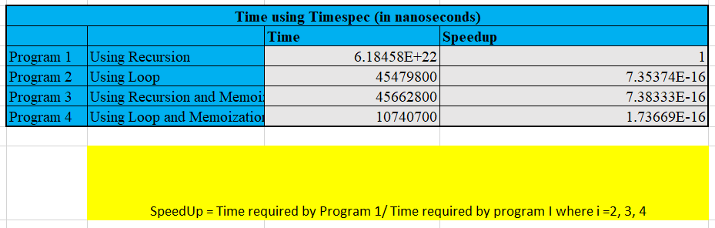

Q2. For the codes, Go to Q1/Programs/

For part (a) and part(b), refer the Excel sheet.

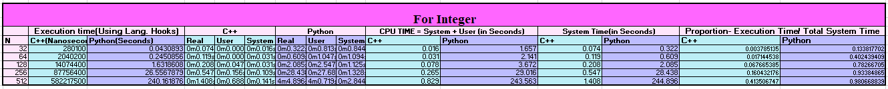



(c) Execution Time vs N

Less the execution time, better is the performance and vice versa.

For integers, with increasing value of N, we can see that Python (240 seconds approx for N = 512) is taking more time than C++ (only a few seconds for N = 512)to execute the program. This implies that C++ is relatively faster than python to execute the program.

Considering the worst-case scenario for both the cases that is for N = 512

Less Execution time implies better performance. For N = 512, time taken by C++ is in seconds while python takes 59 seconds approx. to execute the same program. From this we can conclude that C++ is faster than python even in computing the double values.

Common observation in both the cases is the execution time increase as the value of n increases or in other words we can say that the program becomes slower when n value increases.





Here I have considered Execution Time as CPU time and System Time as Real Time.

In python, we can observe that the system and the execution time are varying nearly same.

In the case of C++, we can observe that in the case of integer, the System time is very less as compared to the program execution time.

In case of double for C++, we can observe that execution time is less than system time but the value of execution time is considerable.